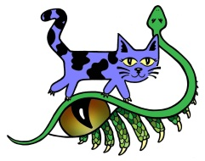Witty Kitties, Inc.  …a shelter for special-needs cats and exotic reptiles…  3133 Roberts Ferry Rd.  Solon, IA 52333  319-848-3238  www.wittykitties.org | ORDER FORM
 | Date: September 8, 2012

ORDERED BY:  Name:  Address:  City, State, Zip:  Phone:  E-mail: | Ship To (IF DIFFERENT):  Name:  Address:  City, State, Zip:  Phone:  E-mail:

Comments or special instructions:

QUANTITY | ADULT or YOUTH | SIZE  S/M/L/XL/XXL | COLOR (red, lt blue, sand, gray)  First Choice/Second Choice | DONATION  AMOUNT | TOTAL
DONATION TOTAL

- Please make checks payable to Witty Kitties, Inc. (Please do not send cash!)
- Mail this completed order form and your donation to Witty Kitties, Inc., 3133 Roberts Ferry Rd., Solon, IA 52333
- Shipping/handling costs donated by members of the board of directors.
- If you have any questions concerning your order, please contact staff@wittykitties.org.

All the witty kitties say meow, and thanks for caring!

